FROM THE DESK OF THE CEO (47/20)
(Follow me on Twitter justchad_cga)
Justin Chadwick 20 November 2020
“Some people feel the rain. Others just get wet” Bob Marley
SOFT CITRUS SEASON REVIEW
There was a time when CGA seriously reconsidered the value in holding CGA Roadshow meetings in the Boland – with less than a handful of growers attending – with more CGA staff than growers at the meetings. Fast forward to 2020 and this region now accounts for 22% of South African soft citrus exports, and with the Western Cape region (Citrusdal and surroundings) at 21%, the Western Cape province now accounts for 43% of South soft citrus export volumes. There has also been considerable expansion in Patensie – now accounting for 13% of South African soft citrus exports, closely followed by Sundays River at 12% (the Eastern Cape accounting for 25% of total South African soft citrus exports). The new CGA region, Burgersfort/Ohrigstad is straight onto the leader board with 11%, followed by neighbouring region Senwes at 10%, Limpopo province representing 21% of soft citrus exports.
The Citrus Marketing Forum (CMF) adopted the Soft Citrus Variety Group’s (VFG) March 2020 estimate of 23.3 million cartons – a whopping 27% increase on 2019’s 18.3 million cartons. This increase was not unexpected – given the plantings over the past number of years.
As the season ends we look back on another excellent estimate by the VFG’s and CMF – the final packed figure is 23.7 m cartons – a mere 1.7% greater than estimate. However, estimation within regions was not as spectacular; Sundays River (-2.7%), Patensie (-3.5%) and Senwes (+3.5%) were under the 5% discrepancy which is deemed excellent; Boland was +7.2% which is considered good. Burgersfort/Ohrigstad could be forgiven for their -16.7% discrepancy as they complete their first year as a separate region, while the Western Cape underestimated the recovery from drought (+27.3%).
Shipping distribution was similar to 2019 – Europe (27%) and UK (24%) absorbing more than half of South Africa’s soft citrus. North America showed a sizable increase in South African soft citrus imports – up from 10% in 2019 to 13% in 2020 (from 1.8 million to 3.1 million cartons). The Middle East also increased from 10% to 11% (1.7 million to 2.6 million cartons). Decreased South African soft citrus imports were experienced in Asia – from 16% (2.8 million cartons) to 13% (2.3 million cartons); and Russia down from 9% to 8%.
From a southern hemisphere angle, Southern Hemisphere Association of Fresh Fruit Exporters (SHAFFE) figures reveal that exports of soft citrus to the USA are the most dominant (almost 320 000 tonnes compared to 220 000 tonnes in 2019), followed by UK (from under 100 000 to over 120 000 tonnes) and Northern Europe (from under 90 000 to over 110 000 tonnes). South America dominates the US market; while South Africa dominates in UK and Europe. John Edmonds (CGA Information Manager) prepared the graphs below from data supplied to SHAFFE.
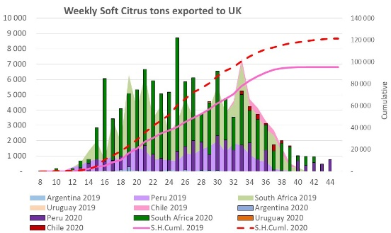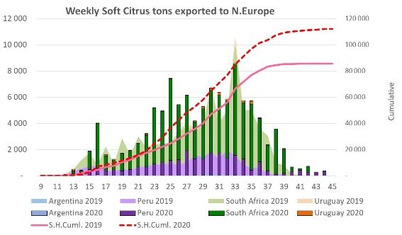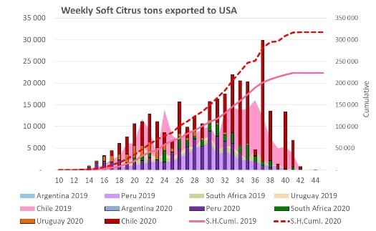
POST SEASON PHYTO ROADSHOW
Citrus fruit producers exporting to China, EU, Iran, Japan, Republic of Korea, Philippines, Thailand, USA & Vietnam markets are invited to participate in the Department of Agriculture, Land Reform and Rural Development (DALRRD), Perishables Products Export Control Board (PPECB) and Citrus Growers Associations (CGA) post-season roadshows to be held as follows: 23/11 Nelspruit Mbombela Municipality Hall 09h00; 24/11 Hoedspruit Blue Mountain Restaurant 14h00; 25/11 Tzaneen Country Lodge 09h00; 26/11 Musina Municipal Show Grounds Agricultural Hall 09h00; 27/11 Marble Hall/Groblersdal Die Raasblaar 09h00; 30/11 Stellenbosch ARC Olive Grove 10h00; 2/12 Nkwaleni Hall 10h00 plus {Virtual Meeting 1/12 – link will be provided}: for more information contact RejoiceM@Dalrrd.gov.za

