***FROM THE DESK OF THE CEO (44/20)***

**(Follow me on Twitter justchad_cga)**

*Justin Chadwick 30 October 2020*

|  |
| --- |
| ***“A grapefruit is just a lemon that saw an opportunity and took advantage of it” Oscar Wilde*** |

**GRAPEFRUIT REVIEW 2020**

This past week over 100 southern African citrus stakeholders convened for the first ever virtual Citrus Marketing Forum (CMF) meeting. Congratulations to Werner van Rooyen of FPEF for seamlessly taking the large audience through the agenda, and managing the technical aspects so admirably.

In this newsletter we will look at the 2020 grapefruit season – with all figures expressed in 17Kg carton equivalents.

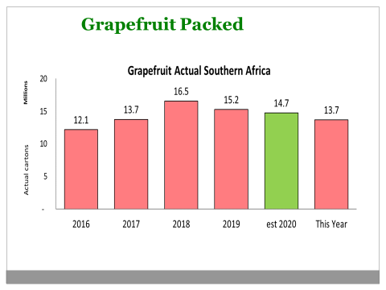

John Edmonds (CGA Information Manager) presented the packed figures for 2020 as compared to previous years, and compared to the original estimate made in March this year.

The actual volume packed was a million cartons above the original estimate – or 7% higher than the March estimate.

Since the record crop of 2018, grapefruit has shown a decline to present levels, with 2020 being 11% less than 2018, and 3% less than last year.



As with other citrus commodities, grapefruit shipping was fast out the blocks, with significantly higher shipping before week 22 (other than week 20). Thereafter, the weekly shipped volumes dropped off faster than the past two years. 2018 was characterized by significant shipping after week 22.

Grapefruit distribution in 2020 mirrored that of 2019 – Europe taking 44%; Asia 33%; Russia 10% and UK and North America both 5%.